Hash Maps in Java
Why HashMap?
Time Complexity of searching in Arrays: O(n) linear search or sorted array: O(log N) binary search.

If we want to search for an element in constant time O(1), we use HashMap. When there is no traversal, no loop needed to search of an element, HashMap are considered.
In HashMap, the elements are stored in key-value pairs.

Name (key) | Marks (value)
Rahul | 88
Kunal | 95
Vishal | 90
Map.get(“Kunal”)

Returns the value 95 in constant time O(1). It will not traverse and search each element; it will directly jump to Kunal and return the value.

Examples:
- Network Routers; Routers route the IP addresses. It uses HashMap.
- DNS Cache; Instead of asking DNS servers repeatedly: Applications first check a local cache (often implemented using hash-based lookups) before performing a network request.
- Graph Algorithms: Dijkstra's shortest path, DFS, BFS

Internal Working of HashMap

0 | 1 | 2 | 3 | 4 | 5 | 6
Kunal |  | Rahul |  | Saksham

Map.get(2) = “Rahul” in constant time. HOW?? Using Hashcode

Problems to use Hashcode:
- We need all elements as positive integers. For this, we will use Hashcode function.
- Hashcode that I get for an element can be very large. For this, we will reduce it. It is known as Hashing. Reduce all elements in table, to a size ‘m’

Definition of Hashcode $→$ A hash code is an integer value generated for an object that helps hash-based data structures (like HashMap, HashSet, and Hash table) quickly determine where to store and find that object.

HashCode Internals:
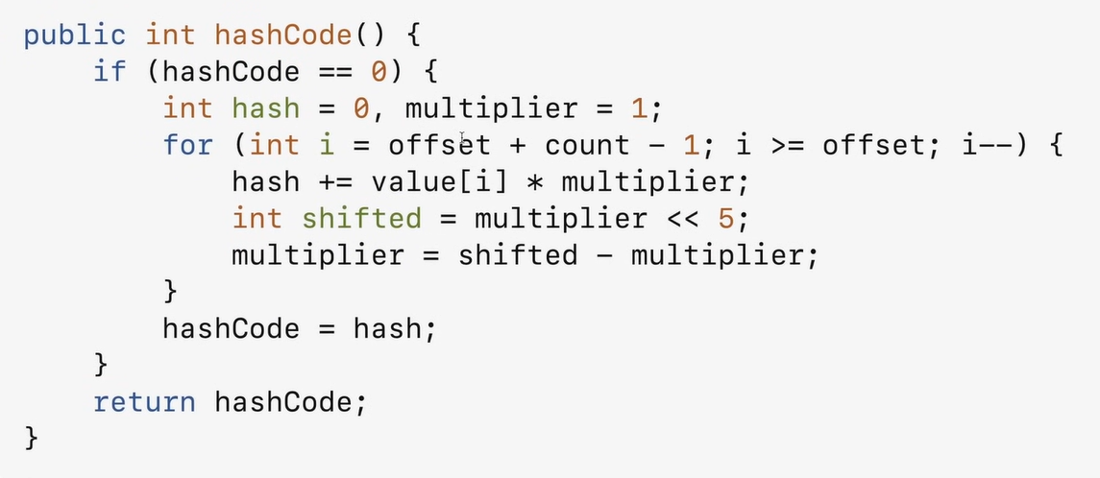

Example:
Let’s suppose, $m=10$ (Size of the table)
0 | 1 | 2 | 3 | 4 | 5 | 6 | 7 | 8 | 9
Kunal |  | Rahul |  | Saksham

“Saksham” $→$ hash(“Saksham”) = 4
Insert Saksham in index 4.
“Rahul” $→$ hash(“Rahul”) = 2
Insert Rahul in index 2

Get the items:
Now, to get the item as well, it will calculate the hash of the element
Map.get(“Saksham”) $→$ hash(“Saksham”) = 4 O(1) $→Amortized Constant Time$

NOTE: But the hashCode is not a small number, so to reduce it, we use Hashing.
hash(“Saksham”) = 47743994 % 10 = 4
Hashing
hash(“Rahul”) = 224343242 % 10 = 2

But every element cannot have unique hashCode after hashing:
hash(“Rahul”) = 224343242 % 10 = 2
Collision
hash(“Chetan”) = 21344542 % 10 = 2

Collision
A collision in hashing occurs when two different keys produce the same hash value or map to the same bucket in a hash table.
Since a hash table has a limited number of buckets but can store many keys, collisions are unavoidable.

Ways to resolve collisions:
There are two ways to resolve collisions:
- Chaining
- Open Addressing

Chaining (Open Hashing) – By Default used by JAVA
Chaining (or Separate Chaining) is a collision resolution technique used in hash tables. When multiple keys map to the same bucket, instead of overwriting the existing entry, all entries are stored together in that bucket using a linked list (or, in Java 8+, sometimes a red-black tree).
Example:
hash(“Rahul”) = 224343242 % 10 = 2
hash(“Chetan”) = 21344542 % 10 = 2
hash(“Kamad”) = 24349892 % 10 = 2
hash(“Abhishek”) = 23909022 % 10 = 2

0 | 1 | 2 | 3 | 4 | 5 | 6 | 7 | 8 | 9
Kunal |  | Rahul |  | Saksham

Chetan

Kamad

Abhishek

Now, one problem arises:
What if every element’s hash comes the same and it forms a huge, Linked List. Now, map.get(“Abhishek”) will have to travel through the Linked List and the time complexity will be O(n)

Solution: We try our best that not all the elements come on the same index all the time. We basically cheat a little bit. We use Simple Uniform Hashing.

SIMPLE UNIFORM HASHING
Assumptions:
Every key is equally likely to be hashed to any slot in the table, independent of where all the previous keys are hashed.
$$n=number of keys in the table$$
$$m=size of the table$$
$$Load factor α=\frac{n}{m}$$
Initial capacity of HashMap is 16
Interview Question: Why is the Load factor 0.75?
Answer: α (load factor) is the ratio of the number of stored elements to the hash table capacity. A value of 0.75 means the table is allowed to become 75% full before resizing. In Java HashMap, the default load factor is 0.75 because it provides a good balance between memory usage and collision reduction.
If the load factor were 1.0:
- The table would become almost completely full before resizing.
- More keys would end up in the same bucket.
- More collisions occur.
- Lookup, insert, and delete become slower because each bucket contains more elements.
If the load factor was 0.5:
- The map resizes much earlier.
- Collisions are very rare.
- Operations become faster.
- But memory usage increases significantly because many buckets remain empty.
A load factor of 0.75 provides a good compromise.
- Reasonably low number of collisions.
- Efficient memory usage.
- Fewer expensive resize operations.
- Maintains average O(1) performance for put(), get(), and remove().

NOTE: If you have $n$ number of items, you want to place in the hash table, total slots are $m$; then Load factor is the expected number of keys for index $i$ (per slot).
TIME COMPLEXITY: $O(1+α)$
1 is for the has function which we apply and got into that index (point) and now for the Linked List, it will be $α$.
Assumption: $α=O\left(1\right)$ when $m=Ω(n)$

Hash Functions used for Re-Hashing:
Whenever the number of entries in HashMap crosses the threshold value, then the bucket size of the HashMap is doubled and re-hashing is done. The already existing entries of the map are copied, and new entries are added to this increased HashMap.
Types of Hash Function:
- Division Method
Size of the array
$$h\left(k\right)=k \% m$$

Generally, m = prime number (not too close to the power of 2 or 10)$→common in the real world$

- Multiplication Method
$$h\left(k\right)=\left[\left(a . k\right) \% 2^{w}\right]≫(w-r)$$
k = key
$a$= an odd constant (multiplier)
$w$= number of bits in a machine word (e.g., 32 or 64)
$r$= number of bits needed for the table size
Table size $m=2^{r}$

- Universal Hashing
$$h\left(k\right)=\left[\left(a.k +b\right) \% p\right] \% m$$
k = Key to be hashed
a = Random multiplier (1 ≤ a ≤ p − 1)
b = Random offset (0 ≤ b ≤ p − 1)
p = Prime number greater than the largest possible key
m = Number of buckets (size of the hash table)
h(k) = Final hash value (bucket index)

Using this formula, the probability that the hash value of key1 = hash value of keys2 ; $p=\frac{1}{m}$.

How to determine the Size of the table:
$$m=θ(n)$$
Big$→Waste of resources$
Small $→Slow$
Idea: Start small and then grow

Double the size of the array:
Initially, suppose we had array of size 5. As soon as we have 5 elements in the table, increase the size of the table by double, i.e. 10
BEFORE:
0 | 1 | 2 | 3 | 4
Kunal | Rohan | Alex | Prashant
Rishabh

AFTER:
0 | 1 | 2 | 3 | 4 | 5 | 6 | 7 | 8 | 9
Kunal | Rohan | Alex | Prashant
Rishabh

When you double the table, the cost to insert $n$ items will be O(n) because it will be
$$O\left(1+2+3+4+…+ n\right)=O(n)$$
Average time for $n$items: O(n)
Average time 1 item: O(1). This is known as Amortized Constant Time or Average Constant Time

Open Addressing (Closed Hashing)
Open Addressing is a collision resolution technique used in hash tables. When a collision occurs, instead of storing multiple elements in the same bucket (as in chaining), the algorithm searches for another empty bucket according to a probing sequence.
Probe $→try$

139
33 (inserted in 3rd try)
46
88

hash(33, 0)

hash(33, 1)

hash(33, 2)
Probing Strategies:
- Linear Probing
Linear Probing is a collision resolution technique used in Open Addressing where, if a collision occurs, the hash table checks the next consecutive slots until an empty position is found.
$$h\left(k, i\right)=\left(h\left(k\right)+i\right) \% m$$

0
M-1

H(k, i) PROBLEM: CLUSTERING, a cluster is being formed because we are jumping every time to the next index.

- Double Hashing
Double Hashing is a collision resolution technique used in Open Addressing where two different hash functions are used to calculate the sequence of positions to check when a collision occurs. Instead of checking the next slot sequentially (like linear probing), double hashing uses a second hash function to decide the jump size.
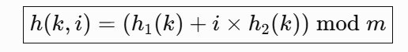
Advantages:
✓ Reduces clustering
✓ Provides better distribution than linear probing
✓ Each key gets a unique probing sequence
✓ Performs well when the table is moderately full

- Quadratic Probing
Checks slots using quadratic intervals to reduce clustering.

Separate Chaining VS Open Addressing
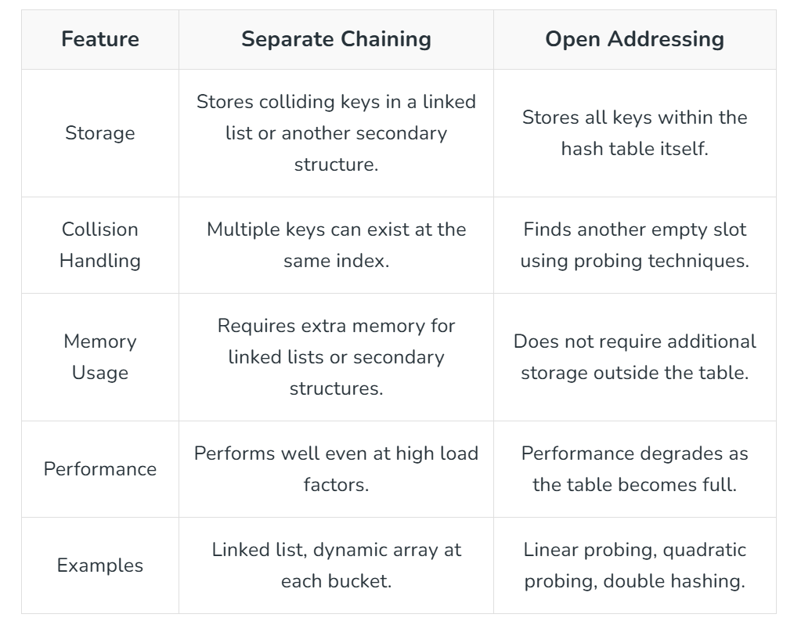

UNIFORM HASHING ASSUMPTION
Every key is equally likely to have m! permutations.
Each key is equally likely to be mapped to any of the $m$slots (buckets) in the hash table, independently of other keys.
In simple words:
- A good hash function should distribute keys randomly and evenly.
- Every possible arrangement of keys among the buckets should have the same probability.

IMPORTANT POINTS
- Can HashMap be used in multi-threaded environment?
HashMap can’t be used for multithreading because it is not Thread-safe.
In HashMap, if one thread is iterating over an object, another thread is trying to access the same object, it throws ConcurrentModificationException.

To avoid this , we can use ConcurrentHashMap.
In ConcurrentHashMap while one thread is iterating, the remaining threads are allowed to perform any modification in a safe manner. In the above program Main thread is updating Map, at the same time child thread is also trying to update the Map object. It will not throw ConcurrentModificationException.

- Hash code of null Key is 0.

HashMap VS ConcurrentHashMap
Property | HashMap | ConcurrentHashMap
Thread safe | HashMap is non-synchronized as well as non-thread-safe which makes it unsuitable for a multithreaded environment. | Concurrent HashMap is synchronized internally and thread-safe which makes it suitable for a multithreaded environment
Null Keys and Null Values | We can store as many null values in a HashMap as we want but only 1 null key can be stored | In Concurrent HashMap null keys, as well as null values, are NOT permitted.

HashMap VS HashTable
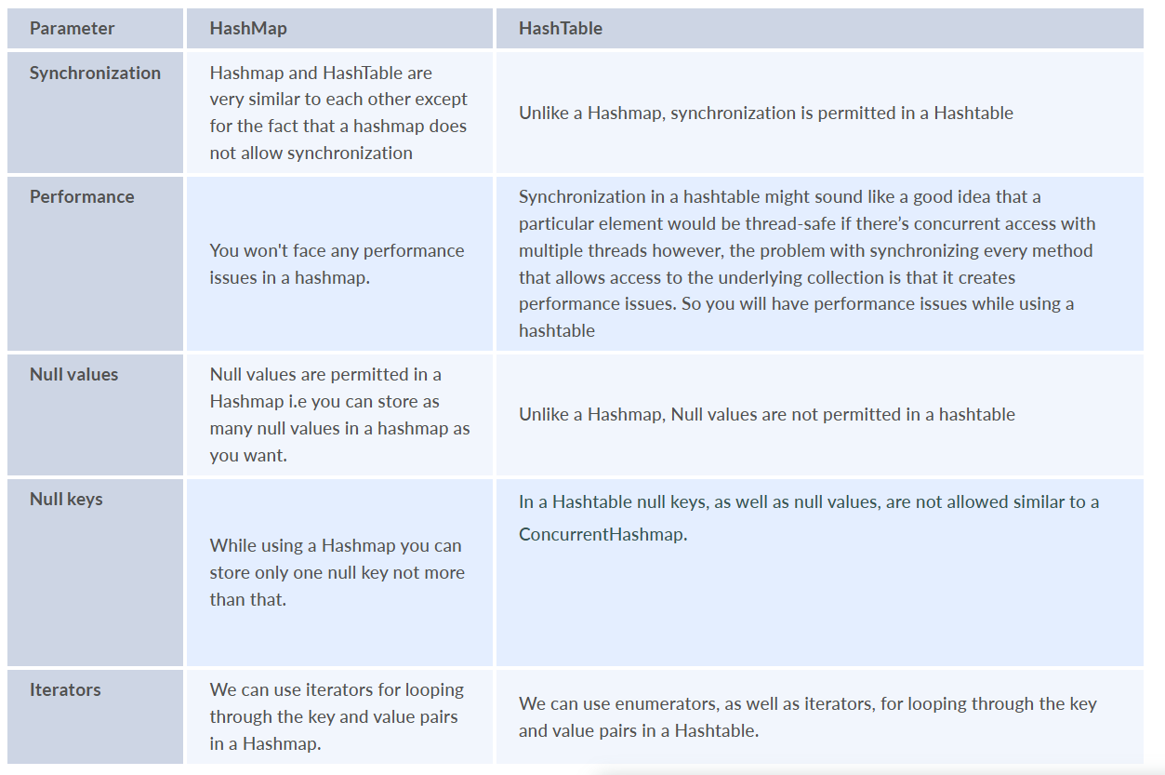

HashMap VS TreeMap
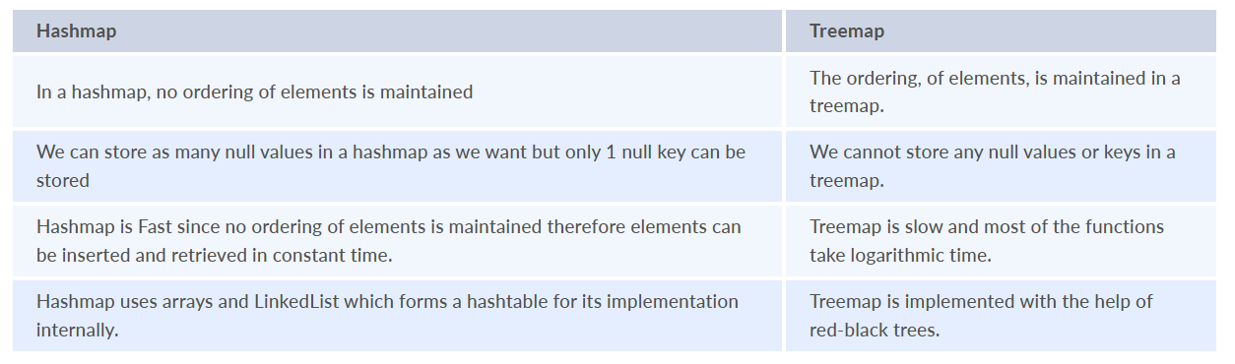

References:
YouTube: KUNAL KUSHAWAHA: Introduction to HashMap & Hash Table in Java
Interview Bit: HashMap Interview Questions
Medium Article: Frequently asked HashMap in Java

